1. **TAX (Responsibility TAX MANAGER)**

**(Tax Configuration > Tax > Tax)**

* **TAB -> Tax Configuration -> TAB -> Tax Regimes**

Main Information

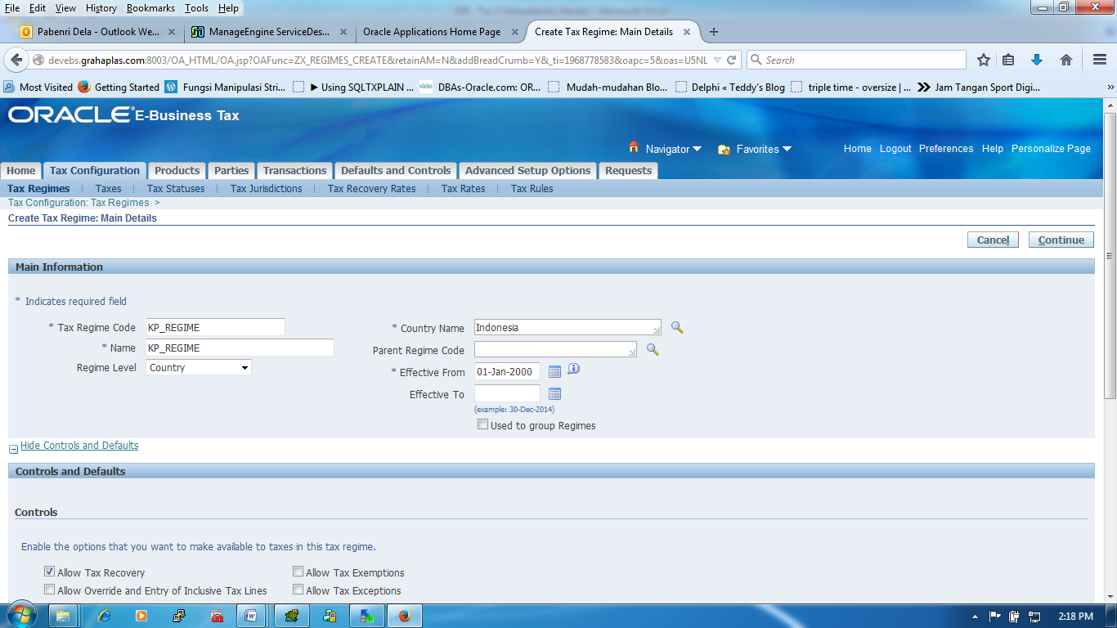

|  |  |  |
| --- | --- | --- |
| Tax Regime Code | : | KP_REGIME |
| Organization Name | : | KP_REGIME |
| Regime Level | : | Country |
| Country Name | : | Indonesia |
| Effective From | : | 01-Jan-2000 |
| Effective To | : | - |
| Used to Group Regimes | : | N |

**Control and Details**

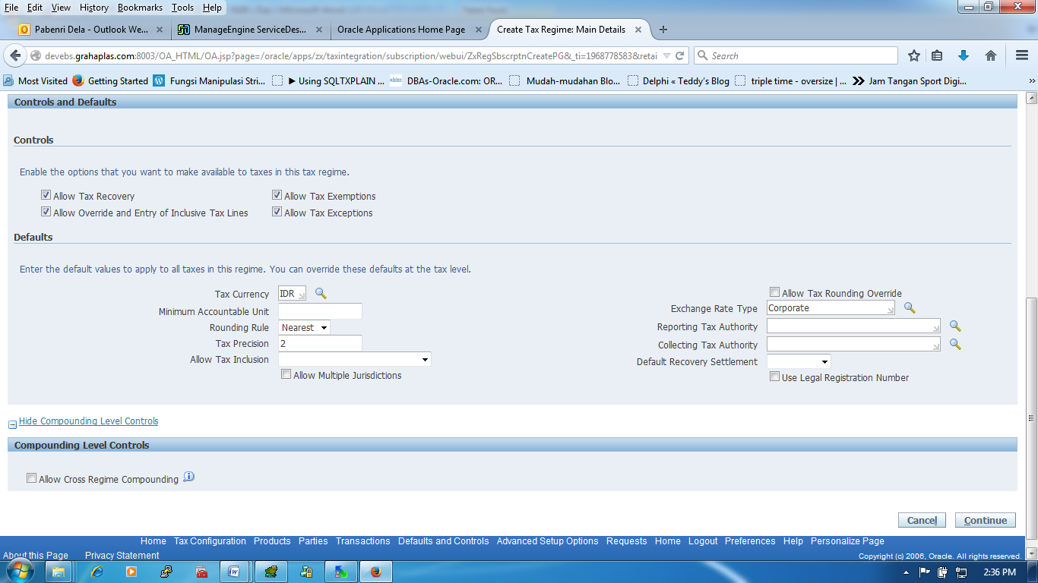

**Button -> Next**

|  |  |  |
| --- | --- | --- |
| Allow Tax Recovery | : | Y |
| Allow Override and Entry of Inclusive Tax Lines | : | Y |
| Allow Tax Exemptions | : | Y |
| Allow Tax Exceptions | : | Y |
|  |  |  |
| Tax Currency | : | IDR |
| Minimum Accountable Unit | : |  |
| Rounding Rule | : | Nearest |
| Tax Precision | : | 2 |
| Allow Tax Inclusion | : |  |
| Allow Multiple Jurisdiction | : |  |
| Allow Tax Rounding Override | : |  |
| Exchange Rate Type | : | Corporate |
| Reporting Tax Authority | : |  |
| Collecting Tax Authority | : |  |
| Default Recovery Settlement | : |  |
| Use Legal Registration Number | : |  |
| Allow Cross Regime Compounding | : | (Blank) |

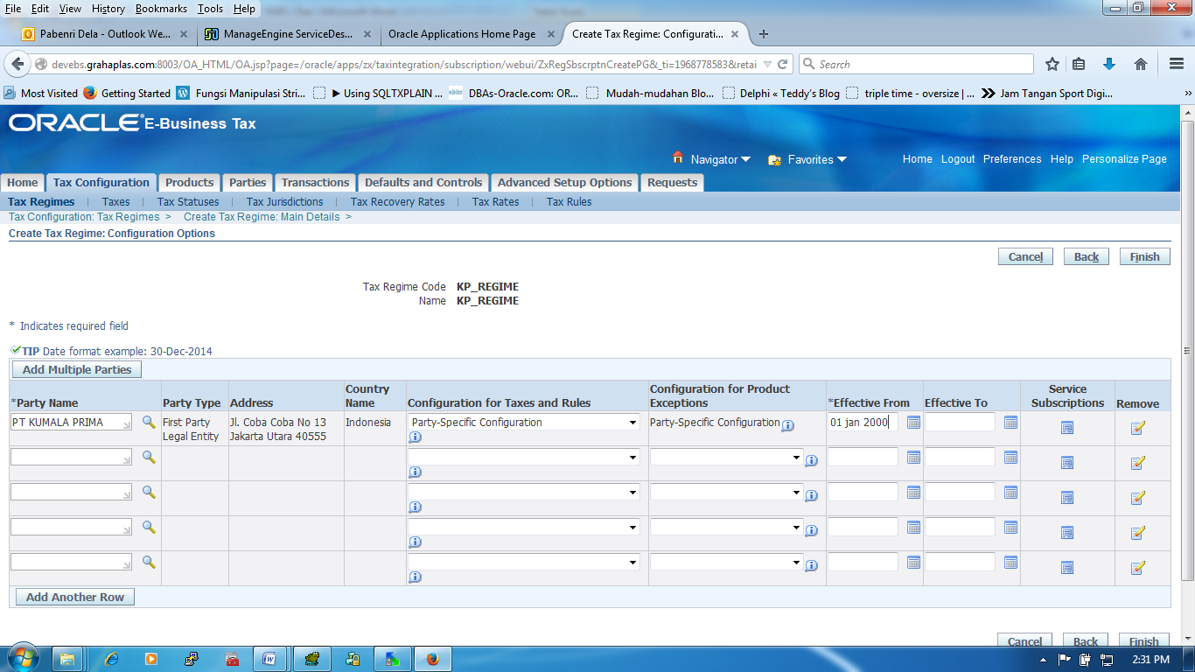

**Button -> Finish**

|  |  |  |
| --- | --- | --- |
| Party Name | : | PT KUMALA PRIMA |
| Party Type | : | First Party Legal Entity |
| Address | : | Jl. Coba Coba No 13 Jakarta Utara |
| Country Name | : | Indonesia |
| Configuration for taxes and Rules | : | Party-Specific Configuration |
| Effective From | : | 01 Jan 2000 |

* **TAB -> Tax Configuration -> TAB -> Taxes**

Main Information

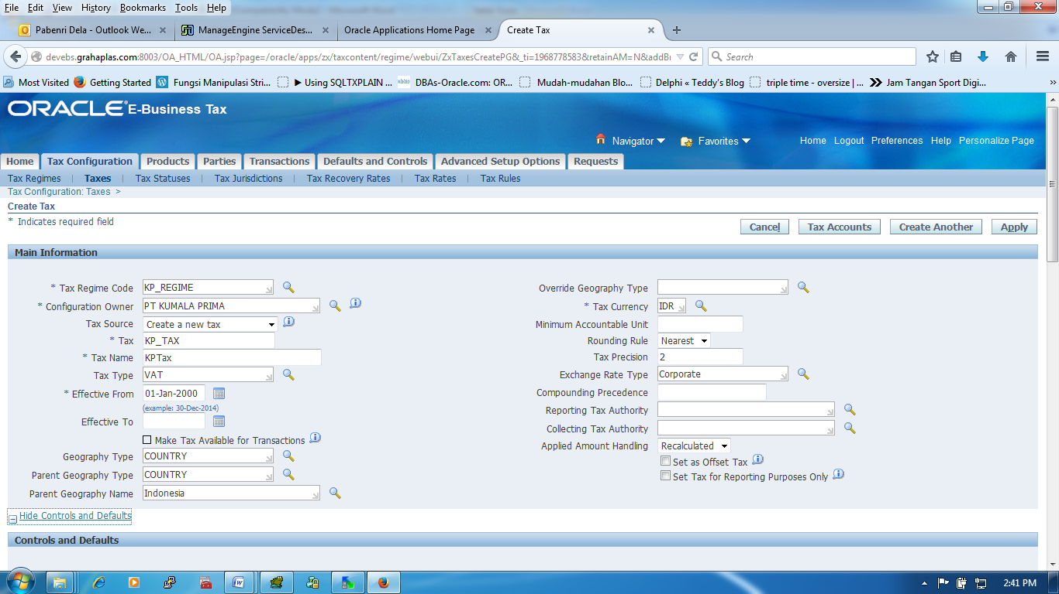

|  |  |  |
| --- | --- | --- |
| Tax Regime Code | : | KP_REGIME |
| Configuration Owner | : | PT KUMALA PRIMA |
| Tax Source | : | Create a new tax |
| Tax | : | KP_TAX |
| Tax Name | : | KPTax |
| Tax Type | : | VAT |
| Effective From | : | 01 Jan 2000 |
| Effective To | : |  |
| Make Tax Available For Transactions | : |  |
| Geography Type | : | COUNTRY |
| Parent Geography Type | : | COUNTRY |
| Parent Geography Name | : |  |
| Override Geography Type | : | Indonesia |
| Tax Currency | : | IDR |
| Minimum Accountable Unit | : |  |
| Rounding Rule | : | Nearest |
| Tax Precision | : | 2 |
| Exchange Rate Type | : | Corporate |
| Compounding Precedence | : |  |
| Reporting Tax Authority | : |  |
| Collecting Tax Authority | : |  |
| Applied Amount Handling | : | Recalculated |
| Set as Offset Tax | : |  |
| Set tax for Reporting Purposes Only | : |  |

Control and Details

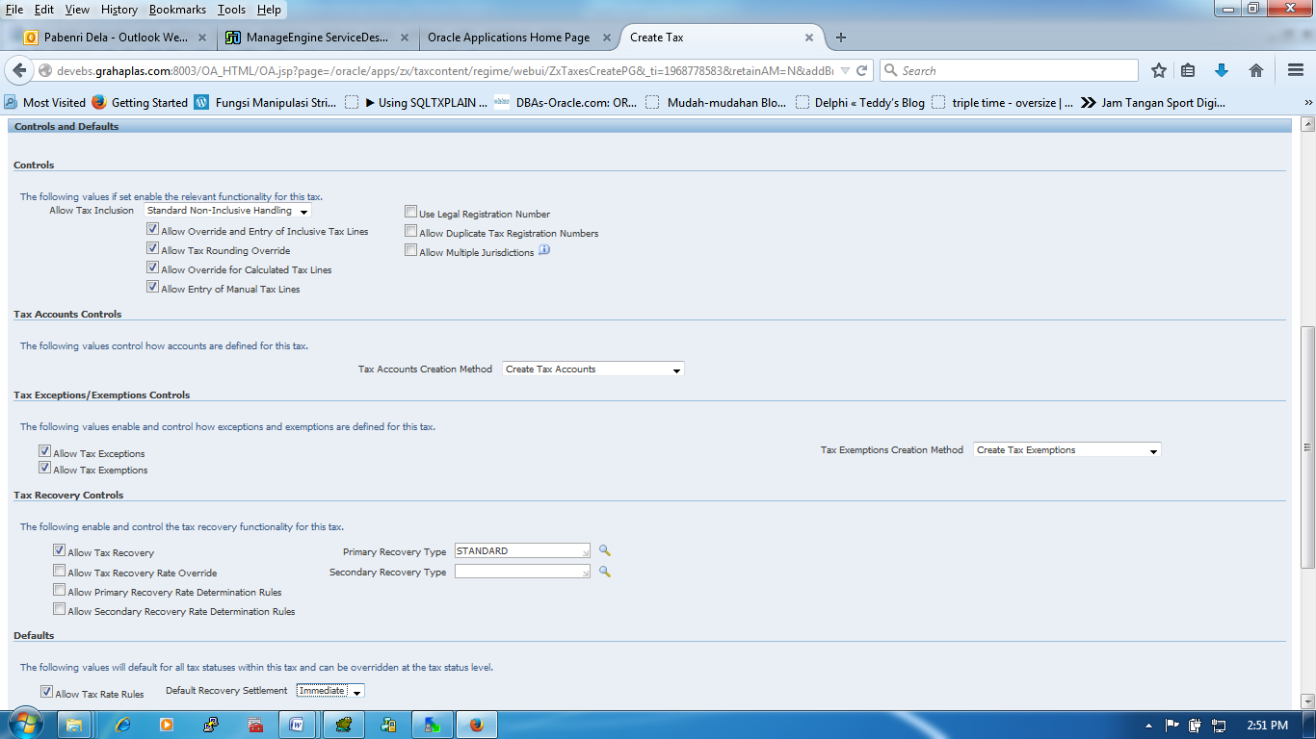

**Button -> Apply**

|  |  |  |
| --- | --- | --- |
| Allow Tax Inclusion | : | Standard Non-Inclusive Handling |
| Allow Override and Entry of Inclusive Tax Lines | : | Y |
| Allow Tax Rounding Override | : | Y |
| Allow Override for Calculated Tax Lines | : | Y |
| Allow Entry of Manual Tax Lines | : | Y |
|  |  |  |
| Tax Accounts Creation Method |  | Create Tax Accounts |
|  |  |  |
| Allow Tax Exceptions | : | Y |
| Allow Tax Exemptions | : | Y |
|  |  |  |
| Allow Tax Recovery | : | Y |
| Allow Tax Recovery Rate Override | : | N |
| Allow Primary Recovery Rate Determination Rules | : | N |
| Aloow Secondary Recovery Rate Determination Rules | : | N |
| Primary Recovery Type | : | STANDARD |
| Default Primary Recovery Rate Code | : | Kosongkan Terlebih Dahulu (Hidden Otomatis) |

* **TAB -> Tax Configuration -> TAB -> Tax Statuses**

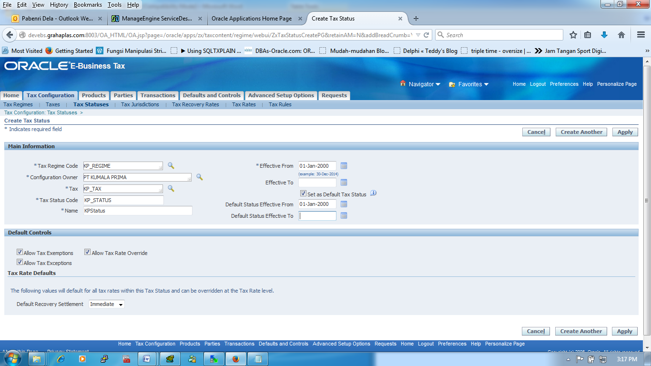

**Button -> Apply**

|  |  |  |
| --- | --- | --- |
| Tax Regime Code | : | KP_REGIME |
| Configuration Owner | : | PT KUMALA PRIMA |
| Tax | : | KP_TAX |
| Tax Status Code | : | KP_STATUS |
| Name | : | KPStatus |
| Effective From | : | 01 Jan 2000 |
| Effective To | : |  |
| Set as Default Tax Status | : | Yes |
| Default Status Effective From | : | 01 Jan 2000 |
| Default Status Effective To | : |  |
|  |  |  |
| Allow Tax Exemptions | : | Yes |
| Allow Tax Exceptions | : | Yes |
| Allow Tax Override | : | Yes |
|  |  |  |
| Default Recovery Settlement | : | Immediate |

* **TAB -> Tax Configuration -> TAB -> Tax Jurisdiction**

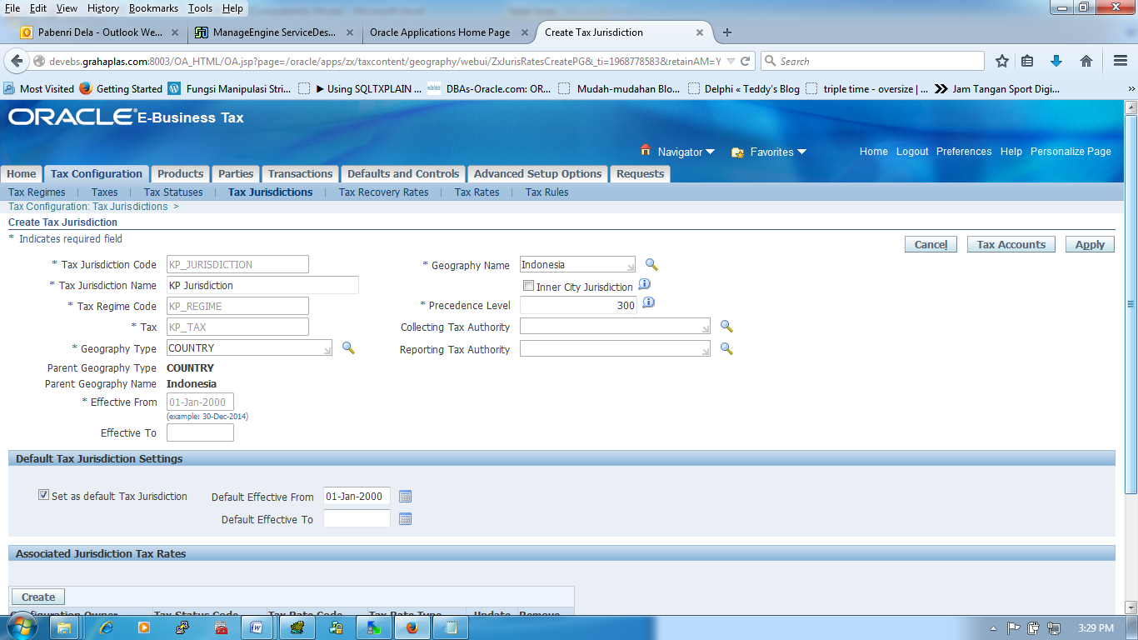

**Button -> Apply**

|  |  |  |
| --- | --- | --- |
| Tax Jurisdiction Code | : | KP_JURISDICTION |
| Tax Jurisdiction Name | : | KP Jurisdiction |
| Tax Regime Code | : | KP_REGIME |
| Tax | : | KP_TAX |
| Geography Type | : | COUNTRY |
| Parent Geography Type | : | COUNTRY |
| Parent Geography Name | : | Indonesia |
| Effective From | : | 01-Jan-2000 |
| Effective To | : |  |
| Geography Name | : | Indonesia |
| Inner City Jurisdiction | : |  |
| Precedence Level | : | 300 |
| Collection Tax Authority | : |  |
| Reporting Tax Authority | : |  |
|  |  |  |
| Set as default Tax Jurisdiction |  | Yes |
| Default Effective From |  | 01-Jan-2000 |

* **TAB -> Tax Configuration -> TAB -> Tax Recovery Rates**

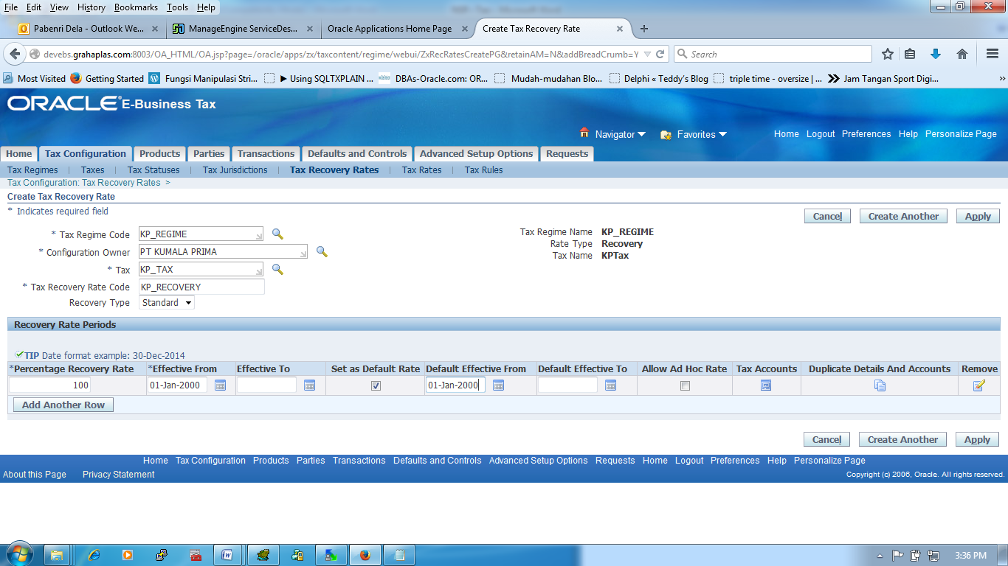

**Button -> Apply**

|  |  |  |
| --- | --- | --- |
| Tax Regime Code | : | KP_REGIME |
| Configuration Owner | : | PT KUMALA PRIMA |
| Tax | : | KP_TAX |
| Tax Recovery Rate Code | : | KP_RECOVERY |
| Recovery Type | : | Standart |
| Tax Regime Name | : | KP_REGIME |
| Rate Type | : | Recovery |
| Tax Name | : | KPTax |
|  |  |  |
| Percentage Recovery Rate | : | 100 |
| Effective From |  | 01-Jan-2000 |
| Effective To | : |  |
| Set as default Rate | : | Yes |
| Default Effective From | : | 01-Jan-2000 |
| Default Effective To |  |  |
| Allow Ad Hoc Rate | : |  |

* **TAB -> Tax Configuration -> TAB -> Tax Rates**

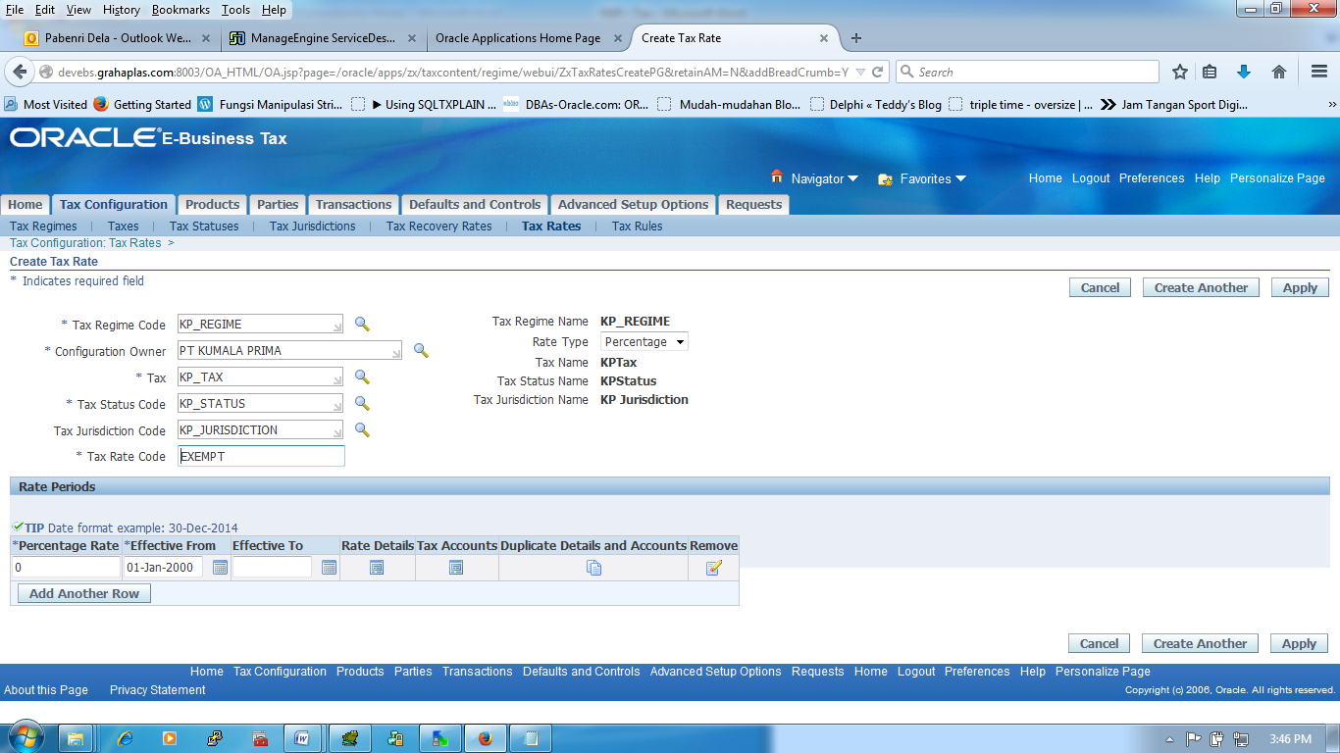

|  |  |  |
| --- | --- | --- |
| Tax Regime Code | : | KP_REGIME |
| Configuration Owner | : | PT. NAMASINDO PLAS |
| Tax | : | KP_TAX |
| Tax Status Code | : | KP_STATUS |
| Tax Jurisdiction Code | : | KP_JURISDICTION |
| Tax Rate Code | : | EXEMPT |
| Tax Regime Name | : | KP_REGIME |
| Rate Type | : | Percentage |
| Tax Name | : | KP Tax |
| Tax Status Name | : | KP Status |
| Tax Jurisdiction Name |  | KPJurisdiction |
|  | : |  |
| Percentage Rate | : | 0 (EXEMPT, PPN 0%) - 1 (PPN 1%) - 10 (PPN 10% , PPN 10% - INCLUSIVE) |
| Effective From | : | 01-Jan-2000 |
| Effective To | : |  |

**Button -> Rate Details**

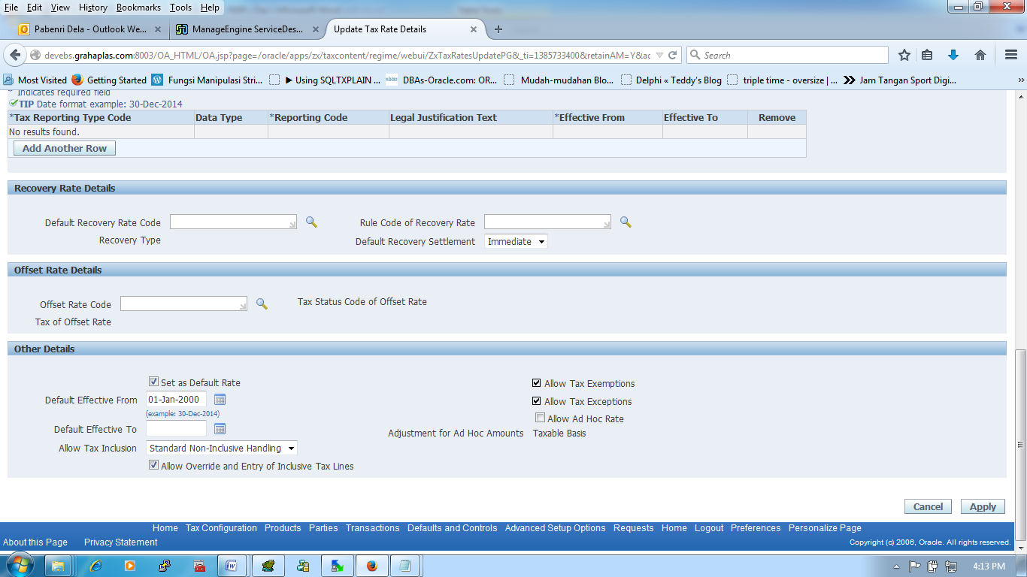

|  |  |  |
| --- | --- | --- |
| Default Recovery Rate Code | : | KP_REGIME |
| Recovery Type | : | PT KUMALA PRIMA |
| Rule Code of Recovery Rate | : | KP_TAX |
| Default Recovery Settlement | : | Immediate |
|  | : |  |
| Set as default Rate | : | Yes |
| Default Effective From | : | 01-Jan-2000 |
| Allow Tax Inclusion | : | Standard Non-Inclusive Handling |
| Allow Override and Entry of Inclusive Tax Lines | : | Yes |
| Allow Tax Exemptions | : | Yes |
| Allow Tax Exceptions |  | Yes |
| Allow Ad Hoc Rate | : |  |
| Adjustment for Ad Hoc Amounts | : | Taxable Basis |

**Button -> Tax Accounts**

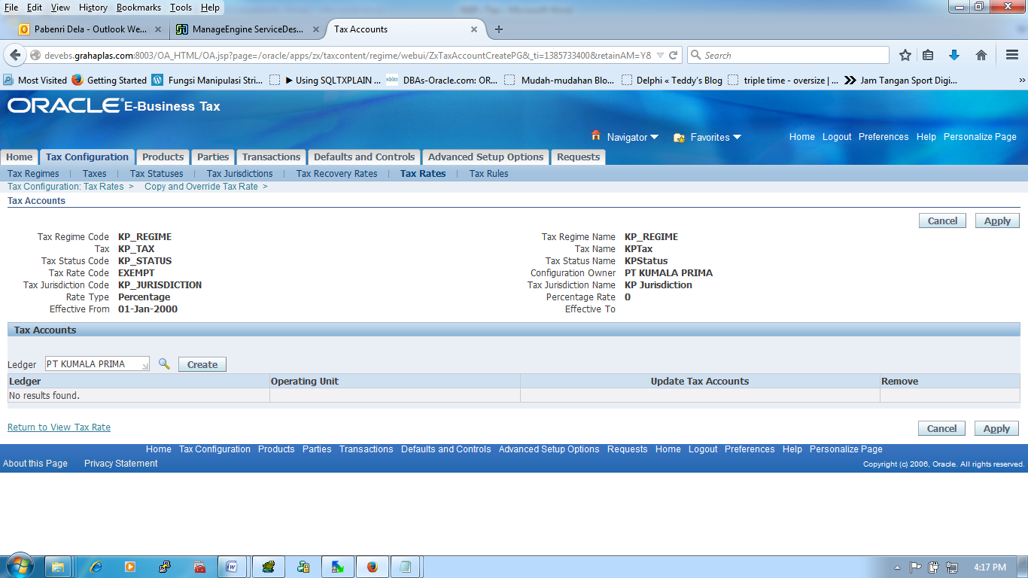

**Button -> Create (Setelah dipilih LE)**

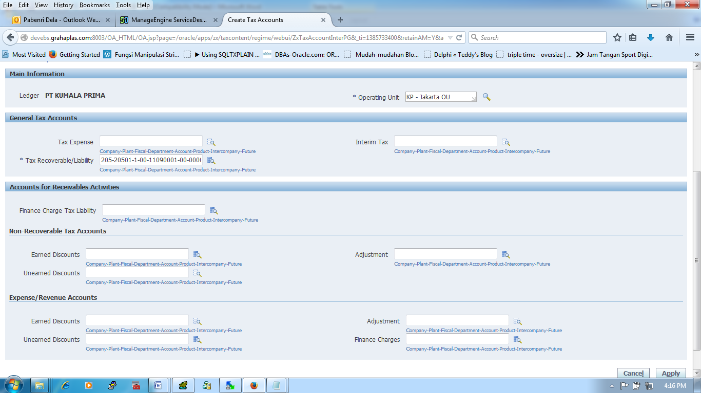

|  |  |  |
| --- | --- | --- |
| Operating Unit | : | KP - Jakarta OU |
| Tax Recoverable/Liability | : | 205-20501-1-00-11090001-00-00000-00 |

* **TAB -> Tax Configuration -> TAB -> Tax Rules (Setting terlebih dahulu "Tax Determining Factor Sets, Tax Condition Sets")**

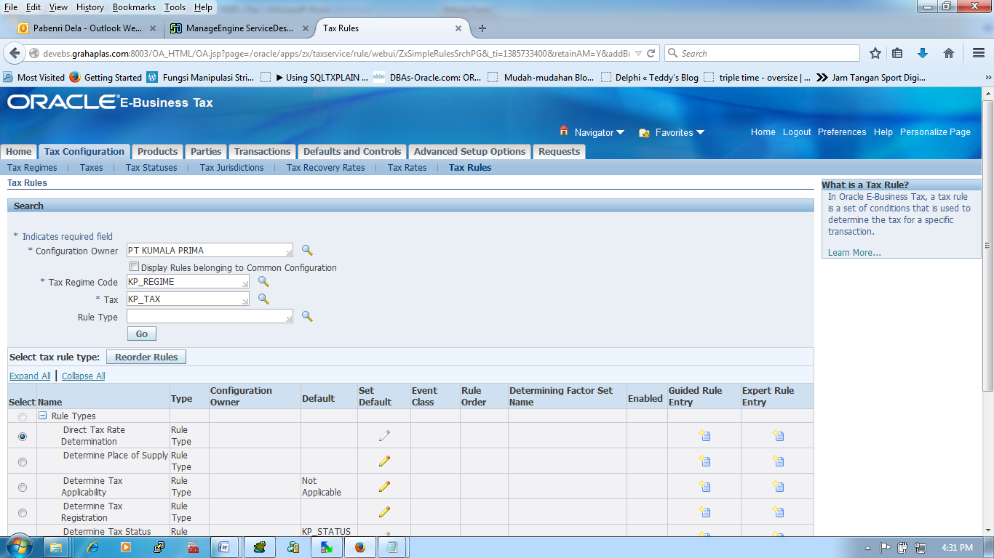

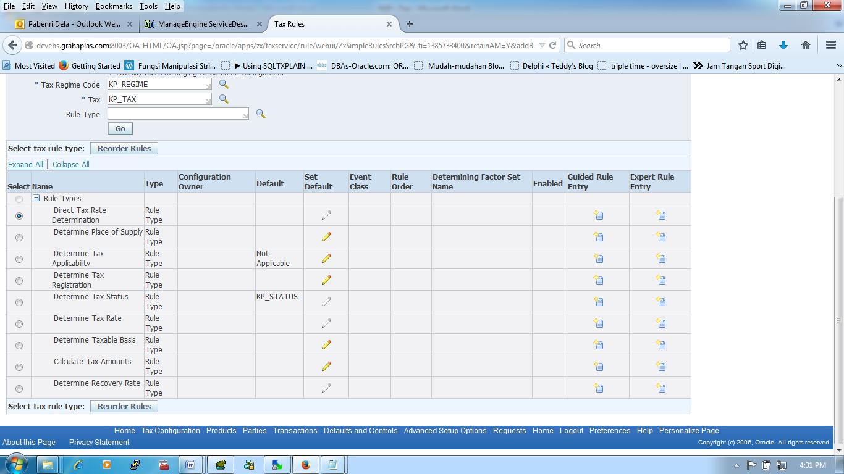

|  |  |  |
| --- | --- | --- |
| Determine Place of Supply (1) | : | Bill To |
| Determine Tax Applicability (5) |  | Not Applicable (Expert Rule Entry) |
| |  |  |  | | --- | --- | --- | | Rule Code | : | TRK_RULE_0 | | Name | : | TRK Rule 0 | | Effective From | : | 01-Jan-2000 | | Determining Factor Set Code | : | TRK_DFS_0 | |  |  |  | | [Determining Factor Class](http://ebsapp.grahaplas.com:8000/OA_HTML/OA.jsp?page=/oracle/apps/zx/taxservice/rule/webui/ZxSimpleRulesSrchPG&_ti=1996745949&retainAM=Y&addBreadCrumb=Y&oapc=23&oas=NioV8u5P_a0tuzBsnSsCHg..) | : | Transaction Input Factor | | [Class Qualifier](http://ebsapp.grahaplas.com:8000/OA_HTML/OA.jsp?page=/oracle/apps/zx/taxservice/rule/webui/ZxAdvRuleConditionsCreatePG&AdvanceRuleStep=2&_ti=1996745949&retainAM=Y&addBreadCrumb=N&oapc=28&oas=EJT5iS1SvRUra9jvpA017w..) | : | <Null) | | [Determining Factor Name](http://ebsapp.grahaplas.com:8000/OA_HTML/OA.jsp?page=/oracle/apps/zx/taxservice/rule/webui/ZxSimpleRulesSrchPG&_ti=1996745949&retainAM=Y&addBreadCrumb=Y&oapc=23&oas=NioV8u5P_a0tuzBsnSsCHg..) | : | Tax Classification Code | | [Required](http://ebsapp.grahaplas.com:8000/OA_HTML/OA.jsp?page=/oracle/apps/zx/taxservice/rule/webui/ZxSimpleRulesSrchPG&_ti=1996745949&retainAM=Y&addBreadCrumb=Y&oapc=23&oas=NioV8u5P_a0tuzBsnSsCHg..) | : | No |  |  |  |  | | --- | --- | --- | | Rule Code | : | TRK_RULE_10 | | Name | : | TRK Rule 10 | | Effective From | : | 01-Jan-2000 | | Determining Factor Set Code | : | TRK_DFS_10 | |  |  |  | | [Determining Factor Class](http://ebsapp.grahaplas.com:8000/OA_HTML/OA.jsp?page=/oracle/apps/zx/taxservice/rule/webui/ZxSimpleRulesSrchPG&_ti=1996745949&retainAM=Y&addBreadCrumb=Y&oapc=23&oas=NioV8u5P_a0tuzBsnSsCHg..) | : | Transaction Input Factor | | [Class Qualifier](http://ebsapp.grahaplas.com:8000/OA_HTML/OA.jsp?page=/oracle/apps/zx/taxservice/rule/webui/ZxAdvRuleConditionsCreatePG&AdvanceRuleStep=2&_ti=1996745949&retainAM=Y&addBreadCrumb=N&oapc=28&oas=EJT5iS1SvRUra9jvpA017w..) | : | <Null) | | [Determining Factor Name](http://ebsapp.grahaplas.com:8000/OA_HTML/OA.jsp?page=/oracle/apps/zx/taxservice/rule/webui/ZxSimpleRulesSrchPG&_ti=1996745949&retainAM=Y&addBreadCrumb=Y&oapc=23&oas=NioV8u5P_a0tuzBsnSsCHg..) | : | Tax Classification Code | | [Required](http://ebsapp.grahaplas.com:8000/OA_HTML/OA.jsp?page=/oracle/apps/zx/taxservice/rule/webui/ZxSimpleRulesSrchPG&_ti=1996745949&retainAM=Y&addBreadCrumb=Y&oapc=23&oas=NioV8u5P_a0tuzBsnSsCHg..) | : | No |  |  |  |  | | --- | --- | --- | | Rule Code | : | TRK_RULE_10_IN | | Name | : | TRK Rule 10 IN | | Effective From | : | 01-Jan-2000 | | Determining Factor Set Code | : | TRK_DFS_10_IN | |  |  |  | | [Determining Factor Class](http://ebsapp.grahaplas.com:8000/OA_HTML/OA.jsp?page=/oracle/apps/zx/taxservice/rule/webui/ZxSimpleRulesSrchPG&_ti=1996745949&retainAM=Y&addBreadCrumb=Y&oapc=23&oas=NioV8u5P_a0tuzBsnSsCHg..) | : | Transaction Input Factor | | [Class Qualifier](http://ebsapp.grahaplas.com:8000/OA_HTML/OA.jsp?page=/oracle/apps/zx/taxservice/rule/webui/ZxAdvRuleConditionsCreatePG&AdvanceRuleStep=2&_ti=1996745949&retainAM=Y&addBreadCrumb=N&oapc=28&oas=EJT5iS1SvRUra9jvpA017w..) | : | <Null) | | [Determining Factor Name](http://ebsapp.grahaplas.com:8000/OA_HTML/OA.jsp?page=/oracle/apps/zx/taxservice/rule/webui/ZxSimpleRulesSrchPG&_ti=1996745949&retainAM=Y&addBreadCrumb=Y&oapc=23&oas=NioV8u5P_a0tuzBsnSsCHg..) | : | Tax Classification Code | | [Required](http://ebsapp.grahaplas.com:8000/OA_HTML/OA.jsp?page=/oracle/apps/zx/taxservice/rule/webui/ZxSimpleRulesSrchPG&_ti=1996745949&retainAM=Y&addBreadCrumb=Y&oapc=23&oas=NioV8u5P_a0tuzBsnSsCHg..) | : | No |  |  |  |  | | --- | --- | --- | | Rule Code | : | TRK_RULE_E | | Name | : | TRK Rule Exempt | | Effective From | : | 01-Jan-2000 | | Determining Factor Set Code | : | TRK_DFS_E | |  |  |  | | [Determining Factor Class](http://ebsapp.grahaplas.com:8000/OA_HTML/OA.jsp?page=/oracle/apps/zx/taxservice/rule/webui/ZxSimpleRulesSrchPG&_ti=1996745949&retainAM=Y&addBreadCrumb=Y&oapc=23&oas=NioV8u5P_a0tuzBsnSsCHg..) | : | Transaction Input Factor | | [Class Qualifier](http://ebsapp.grahaplas.com:8000/OA_HTML/OA.jsp?page=/oracle/apps/zx/taxservice/rule/webui/ZxAdvRuleConditionsCreatePG&AdvanceRuleStep=2&_ti=1996745949&retainAM=Y&addBreadCrumb=N&oapc=28&oas=EJT5iS1SvRUra9jvpA017w..) | : | <Null) | | [Determining Factor Name](http://ebsapp.grahaplas.com:8000/OA_HTML/OA.jsp?page=/oracle/apps/zx/taxservice/rule/webui/ZxSimpleRulesSrchPG&_ti=1996745949&retainAM=Y&addBreadCrumb=Y&oapc=23&oas=NioV8u5P_a0tuzBsnSsCHg..) | : | Tax Classification Code | | [Required](http://ebsapp.grahaplas.com:8000/OA_HTML/OA.jsp?page=/oracle/apps/zx/taxservice/rule/webui/ZxSimpleRulesSrchPG&_ti=1996745949&retainAM=Y&addBreadCrumb=Y&oapc=23&oas=NioV8u5P_a0tuzBsnSsCHg..) | : | No |  |  |  |  | | --- | --- | --- | | Rule Code | : | AMM_RULE_1 | | Name | : | AMM Rule 1 | | Effective From | : | 01-Jan-2000 | | Determining Factor Set Code | : | AMM_DFS_1 | |  |  |  | | [Determining Factor Class](http://ebsapp.grahaplas.com:8000/OA_HTML/OA.jsp?page=/oracle/apps/zx/taxservice/rule/webui/ZxSimpleRulesSrchPG&_ti=1996745949&retainAM=Y&addBreadCrumb=Y&oapc=23&oas=NioV8u5P_a0tuzBsnSsCHg..) | : | Transaction Input Factor | | [Class Qualifier](http://ebsapp.grahaplas.com:8000/OA_HTML/OA.jsp?page=/oracle/apps/zx/taxservice/rule/webui/ZxAdvRuleConditionsCreatePG&AdvanceRuleStep=2&_ti=1996745949&retainAM=Y&addBreadCrumb=N&oapc=28&oas=EJT5iS1SvRUra9jvpA017w..) | : | <Null) | | [Determining Factor Name](http://ebsapp.grahaplas.com:8000/OA_HTML/OA.jsp?page=/oracle/apps/zx/taxservice/rule/webui/ZxSimpleRulesSrchPG&_ti=1996745949&retainAM=Y&addBreadCrumb=Y&oapc=23&oas=NioV8u5P_a0tuzBsnSsCHg..) | : | Tax Classification Code | | [Required](http://ebsapp.grahaplas.com:8000/OA_HTML/OA.jsp?page=/oracle/apps/zx/taxservice/rule/webui/ZxSimpleRulesSrchPG&_ti=1996745949&retainAM=Y&addBreadCrumb=Y&oapc=23&oas=NioV8u5P_a0tuzBsnSsCHg..) | : | No |   **Button -> Next**     |  |  |  | | --- | --- | --- | | Condition Set Code | : | TRK_RULE_0 | | Name | : | TRK Rule 0 | | Order | : | 01-Jan-2000 | | Result | : | Applicable | |  |  |  | | [Determining Factor Class](http://ebsapp.grahaplas.com:8000/OA_HTML/OA.jsp?page=/oracle/apps/zx/taxservice/rule/webui/ZxSimpleRulesSrchPG&_ti=1996745949&retainAM=Y&addBreadCrumb=Y&oapc=23&oas=NioV8u5P_a0tuzBsnSsCHg..) | : | Transaction Input Factor | | [Class Qualifier](http://ebsapp.grahaplas.com:8000/OA_HTML/OA.jsp?page=/oracle/apps/zx/taxservice/rule/webui/ZxAdvRuleConditionsCreatePG&AdvanceRuleStep=2&_ti=1996745949&retainAM=Y&addBreadCrumb=N&oapc=28&oas=EJT5iS1SvRUra9jvpA017w..) | : | <Null) | | [Determining Factor Name](http://ebsapp.grahaplas.com:8000/OA_HTML/OA.jsp?page=/oracle/apps/zx/taxservice/rule/webui/ZxSimpleRulesSrchPG&_ti=1996745949&retainAM=Y&addBreadCrumb=Y&oapc=23&oas=NioV8u5P_a0tuzBsnSsCHg..) | : | Tax Classification Code | | Operator |  | Equal To | | Value/From Range |  | PPN 0% | | To Range |  |  | | Ignore Condition | : | No |  |  |  |  | | --- | --- | --- | | Condition Set Code | : | TRK_CS_10 | | Name | : | TRK CS 10 | | Order | : | 01-Jan-2000 | | Result | : | Applicable | |  |  |  | | [Determining Factor Class](http://ebsapp.grahaplas.com:8000/OA_HTML/OA.jsp?page=/oracle/apps/zx/taxservice/rule/webui/ZxSimpleRulesSrchPG&_ti=1996745949&retainAM=Y&addBreadCrumb=Y&oapc=23&oas=NioV8u5P_a0tuzBsnSsCHg..) | : | Transaction Input Factor | | [Class Qualifier](http://ebsapp.grahaplas.com:8000/OA_HTML/OA.jsp?page=/oracle/apps/zx/taxservice/rule/webui/ZxAdvRuleConditionsCreatePG&AdvanceRuleStep=2&_ti=1996745949&retainAM=Y&addBreadCrumb=N&oapc=28&oas=EJT5iS1SvRUra9jvpA017w..) | : | <Null) | | [Determining Factor Name](http://ebsapp.grahaplas.com:8000/OA_HTML/OA.jsp?page=/oracle/apps/zx/taxservice/rule/webui/ZxSimpleRulesSrchPG&_ti=1996745949&retainAM=Y&addBreadCrumb=Y&oapc=23&oas=NioV8u5P_a0tuzBsnSsCHg..) | : | Tax Classification Code | | Operator |  | Equal To | | Value/From Range |  | PPN 10% | | To Range |  |  | | Ignore Condition | : | No |  |  |  |  | | --- | --- | --- | | Condition Set Code | : | TRK_CS_10_IN | | Name | : | TRK CS 10 IN | | Order | : | 01-Jan-2000 | | Result | : | Applicable | |  |  |  | | [Determining Factor Class](http://ebsapp.grahaplas.com:8000/OA_HTML/OA.jsp?page=/oracle/apps/zx/taxservice/rule/webui/ZxSimpleRulesSrchPG&_ti=1996745949&retainAM=Y&addBreadCrumb=Y&oapc=23&oas=NioV8u5P_a0tuzBsnSsCHg..) | : | Transaction Input Factor | | [Class Qualifier](http://ebsapp.grahaplas.com:8000/OA_HTML/OA.jsp?page=/oracle/apps/zx/taxservice/rule/webui/ZxAdvRuleConditionsCreatePG&AdvanceRuleStep=2&_ti=1996745949&retainAM=Y&addBreadCrumb=N&oapc=28&oas=EJT5iS1SvRUra9jvpA017w..) | : | <Null) | | [Determining Factor Name](http://ebsapp.grahaplas.com:8000/OA_HTML/OA.jsp?page=/oracle/apps/zx/taxservice/rule/webui/ZxSimpleRulesSrchPG&_ti=1996745949&retainAM=Y&addBreadCrumb=Y&oapc=23&oas=NioV8u5P_a0tuzBsnSsCHg..) | : | Tax Classification Code | | Operator |  | Equal To | | Value/From Range |  | PPN 10% - INCLUSIVE | | To Range |  |  | | Ignore Condition | : | No |  |  |  |  | | --- | --- | --- | | Condition Set Code | : | TRK_CS_E | | Name | : | TRK CS Exempt | | Order | : | 01-Jan-2000 | | Result | : | Applicable | |  |  |  | | [Determining Factor Class](http://ebsapp.grahaplas.com:8000/OA_HTML/OA.jsp?page=/oracle/apps/zx/taxservice/rule/webui/ZxSimpleRulesSrchPG&_ti=1996745949&retainAM=Y&addBreadCrumb=Y&oapc=23&oas=NioV8u5P_a0tuzBsnSsCHg..) | : | Transaction Input Factor | | [Class Qualifier](http://ebsapp.grahaplas.com:8000/OA_HTML/OA.jsp?page=/oracle/apps/zx/taxservice/rule/webui/ZxAdvRuleConditionsCreatePG&AdvanceRuleStep=2&_ti=1996745949&retainAM=Y&addBreadCrumb=N&oapc=28&oas=EJT5iS1SvRUra9jvpA017w..) | : | <Null) | | [Determining Factor Name](http://ebsapp.grahaplas.com:8000/OA_HTML/OA.jsp?page=/oracle/apps/zx/taxservice/rule/webui/ZxSimpleRulesSrchPG&_ti=1996745949&retainAM=Y&addBreadCrumb=Y&oapc=23&oas=NioV8u5P_a0tuzBsnSsCHg..) | : | Tax Classification Code | | Operator |  | Equal To | | Value/From Range |  | EXEMPT | | To Range |  |  | | Ignore Condition | : | No |  |  |  |  | | --- | --- | --- | | Condition Set Code | : | AMM_CS_1 | | Name | : | AMM CS 1 | | Order | : | 01-Jan-2000 | | Result | : | Applicable | |  |  |  | | [Determining Factor Class](http://ebsapp.grahaplas.com:8000/OA_HTML/OA.jsp?page=/oracle/apps/zx/taxservice/rule/webui/ZxSimpleRulesSrchPG&_ti=1996745949&retainAM=Y&addBreadCrumb=Y&oapc=23&oas=NioV8u5P_a0tuzBsnSsCHg..) | : | Transaction Input Factor | | [Class Qualifier](http://ebsapp.grahaplas.com:8000/OA_HTML/OA.jsp?page=/oracle/apps/zx/taxservice/rule/webui/ZxAdvRuleConditionsCreatePG&AdvanceRuleStep=2&_ti=1996745949&retainAM=Y&addBreadCrumb=N&oapc=28&oas=EJT5iS1SvRUra9jvpA017w..) | : | <Null) | | [Determining Factor Name](http://ebsapp.grahaplas.com:8000/OA_HTML/OA.jsp?page=/oracle/apps/zx/taxservice/rule/webui/ZxSimpleRulesSrchPG&_ti=1996745949&retainAM=Y&addBreadCrumb=Y&oapc=23&oas=NioV8u5P_a0tuzBsnSsCHg..) | : | Tax Classification Code | | Operator |  | Equal To | | Value/From Range |  | PPN 1% | | To Range |  |  | | Ignore Condition | : | No |   **Button -> Finish** | | |
| Determine Tax Registration |  | Bill From Party |
| Determine Tax Status |  | * Untuk Penambahan sama dengan "Determine Tax Applicability" yang beda hanya di " Result" setelah button -> Next |
| Determine Tax Rate (6) |  |  |
| **Button -> Next** | | |
| Determine Taxable Basis (3) |  | STANDARD_TB |
| Calculate Tax Amounts (4) |  | STANDARD_TC |
|  |  |  |

**(Tax Configuration > Advanced Setup Optons > Tax Determining Factor Sets)**

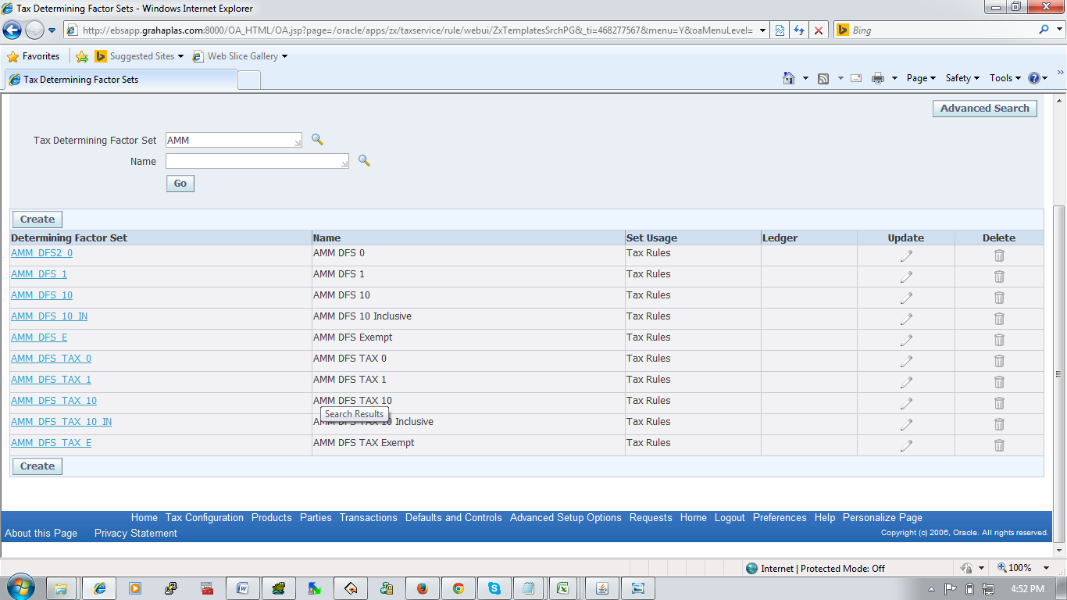

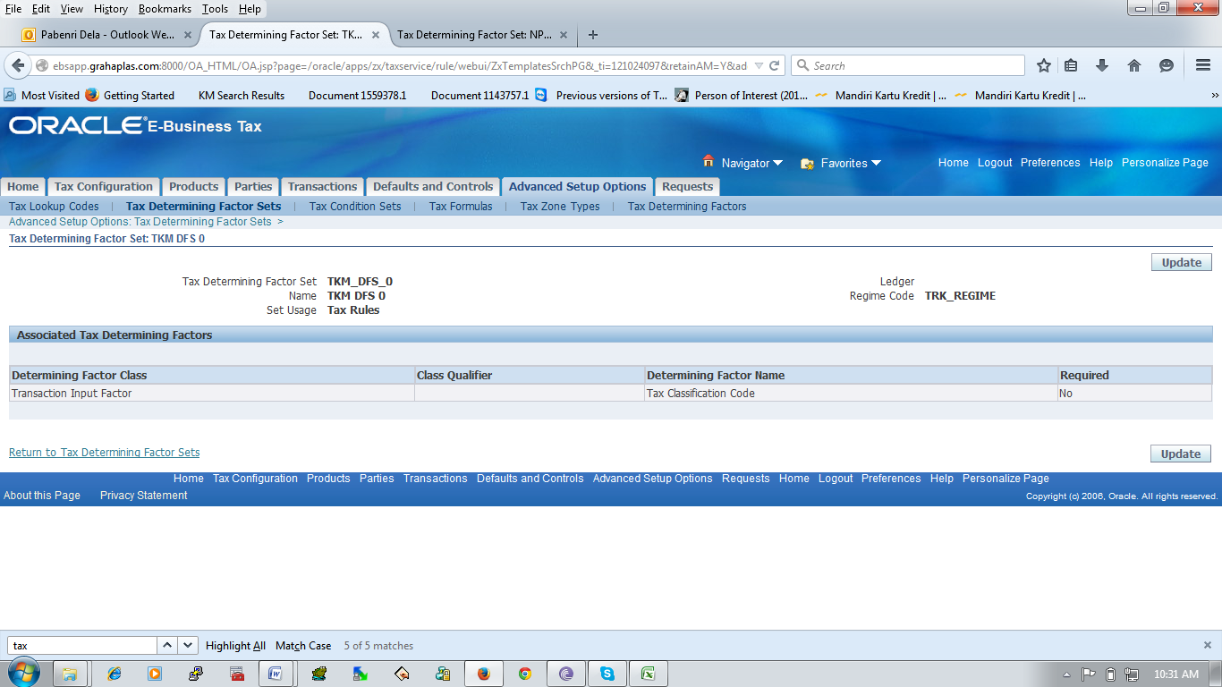

|  |  |  |
| --- | --- | --- |
| Tax Determining Factor Set | : | KP_REGIME |
| Name | : | PT. NAMASINDO PLAS |
| Set Usage | : | Tax Rules |
| Ledger | : | KP_STATUS |
| Regime Code | : | KP_JURISDICTION |

|  |  |  |
| --- | --- | --- |
| Determining Factor Class | : | Transaction Input Factor |
| Class Qualifier | : |  |
| Determining Factor Name | : | Tax Classification Code |
| [**Required**](http://ebsapp.grahaplas.com:8000/OA_HTML/OA.jsp?page=/oracle/apps/zx/taxservice/rule/webui/ZxTemplatesSrchPG&_ti=468277567&retainAM=Y&addBreadCrumb=N&oapc=135&oas=SzOFXviAN8TkDDMWK9_HWQ..) | : | No |

**(Tax Configuration > Advanced Setup Optons > Tax Determining Factor Sets)**

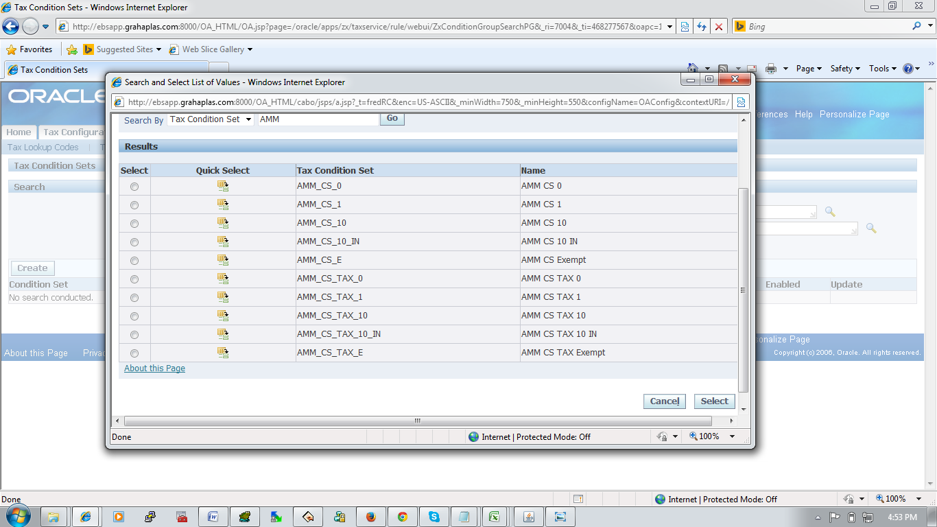

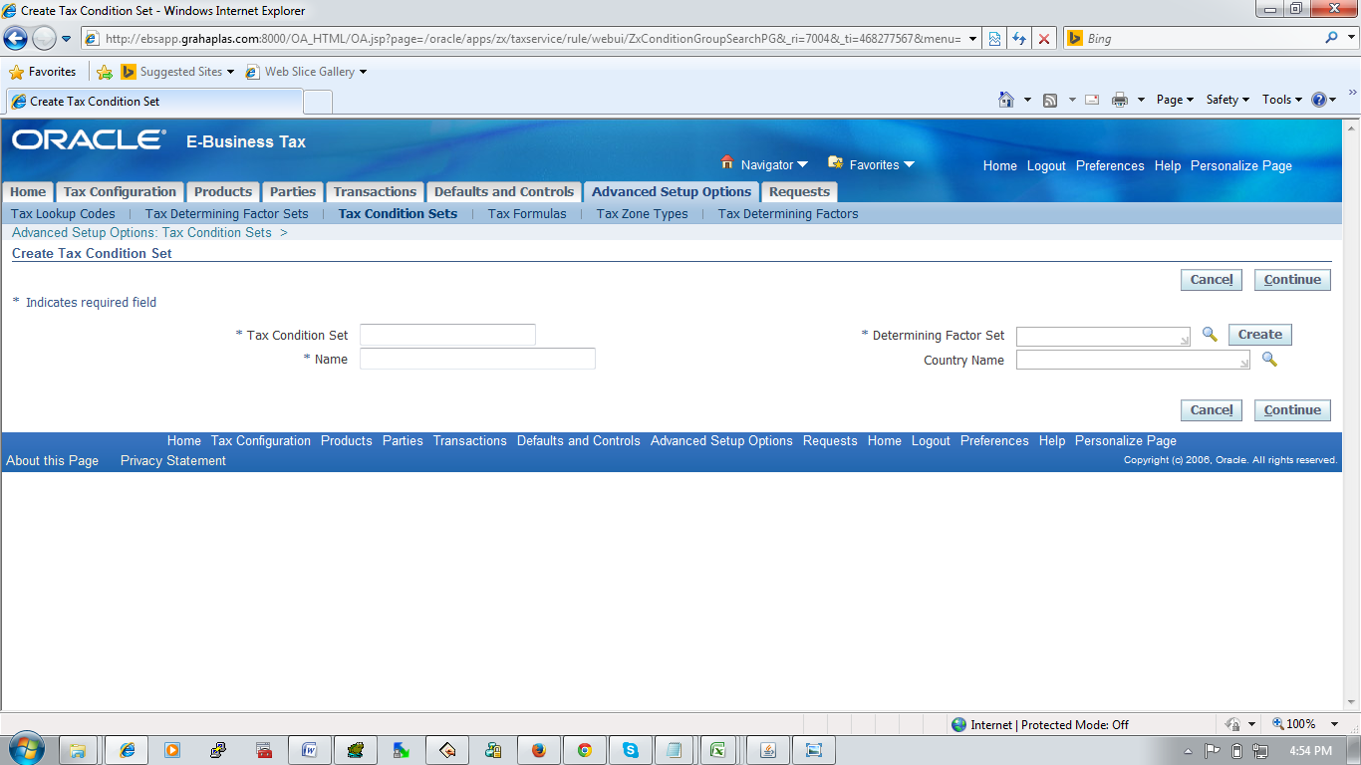

|  |  |  |
| --- | --- | --- |
| Tax Condition Set | : |  |
| Name | : |  |
| Determining Factor Set | : |  |
| Country Name | : | <NULL> |

* **Party Tax Profile (**

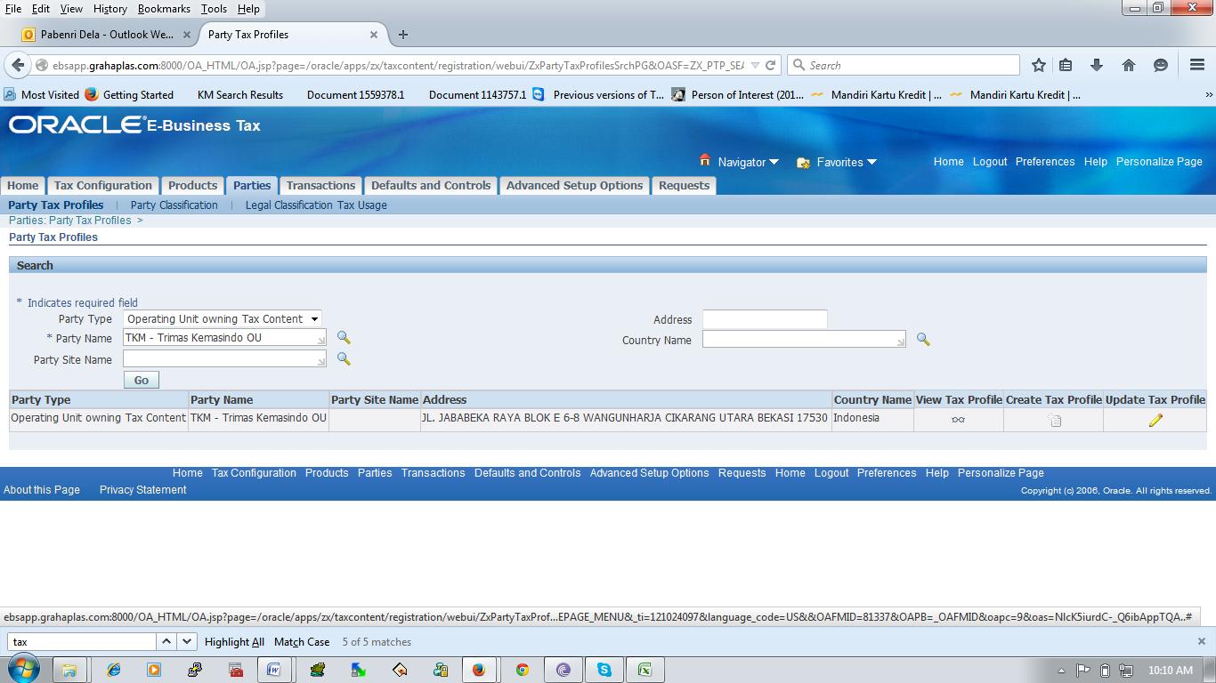

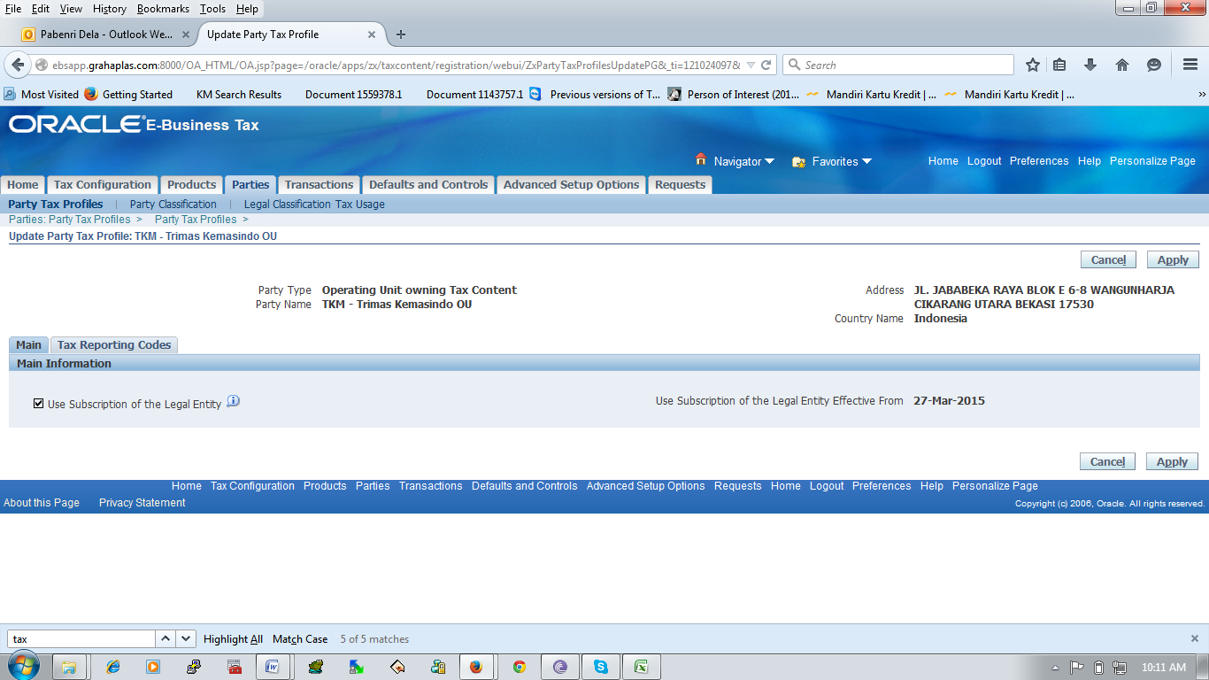

* **dfdfdf**